Urban Resilience and Infrastructure Service Gap Analysis
Table of Contents
- Introduction: Project Scope and Objective
- Section 1: The Base Map – Establishing the Urban Canvas
  - Figure 1: Base Map of Ward
- Section 2: Vertical Density and Land Use Dynamics
  - Figure 2: Building Height Map with Land Use
- Section 3: Essential Services and Social Infrastructure
  - Figure 3: Social Infrastructure Map of the Ward
- Section 4: Safety Assessment – Fire Station Response Coverage
  - Figure 4: Safe & Unsafe Zone: Fire Station Coverage (500m)
- Section 5: Environmental Risk and Infrastructure Expansion
  - Figure 5: Trees Within 5m of Minor Road
- Summary of Findings and Strategic Recommendations

1. Introduction: Project Scope and Objective
This study provides a multi-dimensional spatial assessment of a localized municipal ward. By leveraging QGIS, the analysis identifies critical intersections between built-up density, public service accessibility, and environmental preservation. The goal is to move beyond simple mapping to identify "service gaps" - areas where infrastructure fails to meet the safety and social needs of the population.

2. Section 1: The Base Map - Establishing the Urban Canvas
To understand the ward, we must first establish its physical boundaries and primary arteries. This base map serves as the foundation, identifying the natural and man-made features such as water bodies and rail lines that dictate the ward's growth and connectivity.

Figure 1: Base Map of Ward
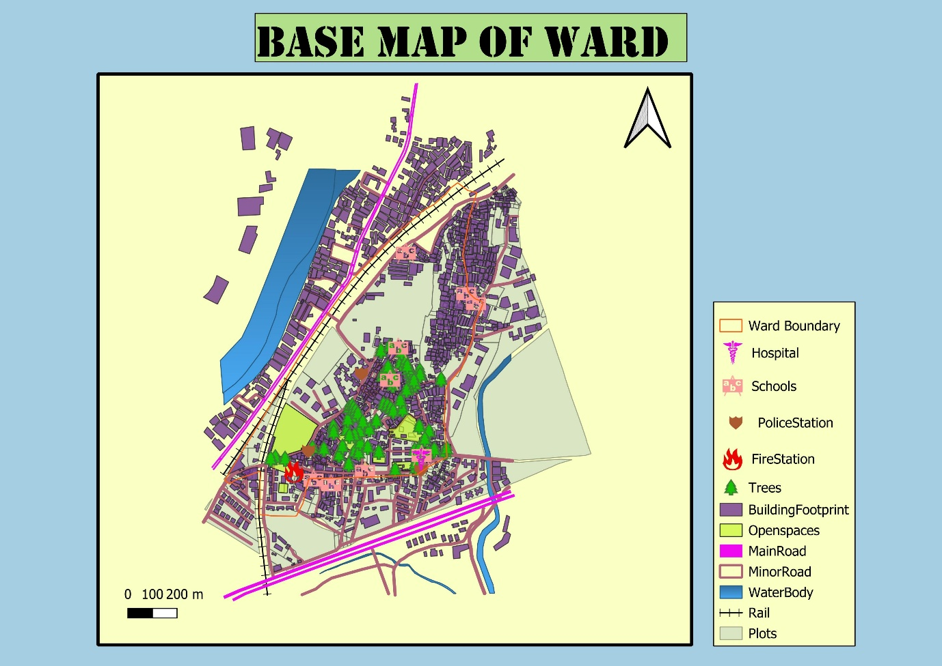

3. Section 2: Vertical Density and Land Use Dynamics
Having established the footprint, we look at the "third dimension" - height and purpose. This map categorizes the ward by land use (residential vs. industrial) and building height.
Insight: Most residential structures are low-rise (0 - 4m), while institutional and industrial pockets show moderate vertical growth. This data is crucial for predicting population density and assessing the load on local utilities.

Figure 2: Building Height Map with Land Use
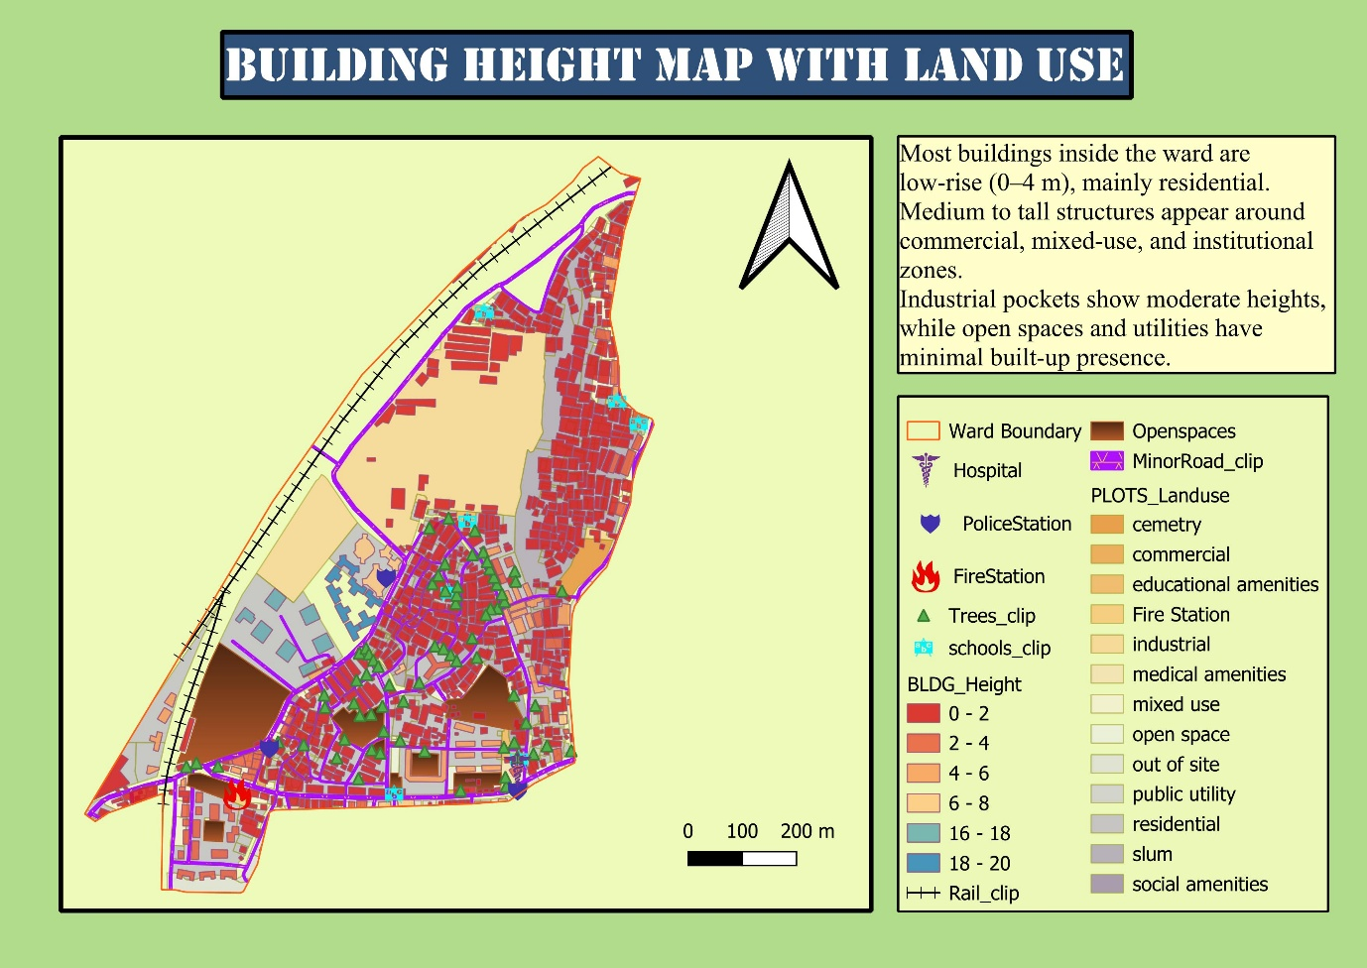

4. Section 3: Essential Services and Social Infrastructure
With the population density mapped, the next logical step is to locate the services that support them. This map identifies the "Social Infrastructure" - the schools, hospitals, and police stations that act as the ward's life support system.
Insight: While the ward has a high concentration of schools (Municipal Marathi and Urdu schools), their physical distribution reveals potential accessibility hurdles for residents in peripheral zones.

Figure 3: Social Infrastructure Map of the Ward
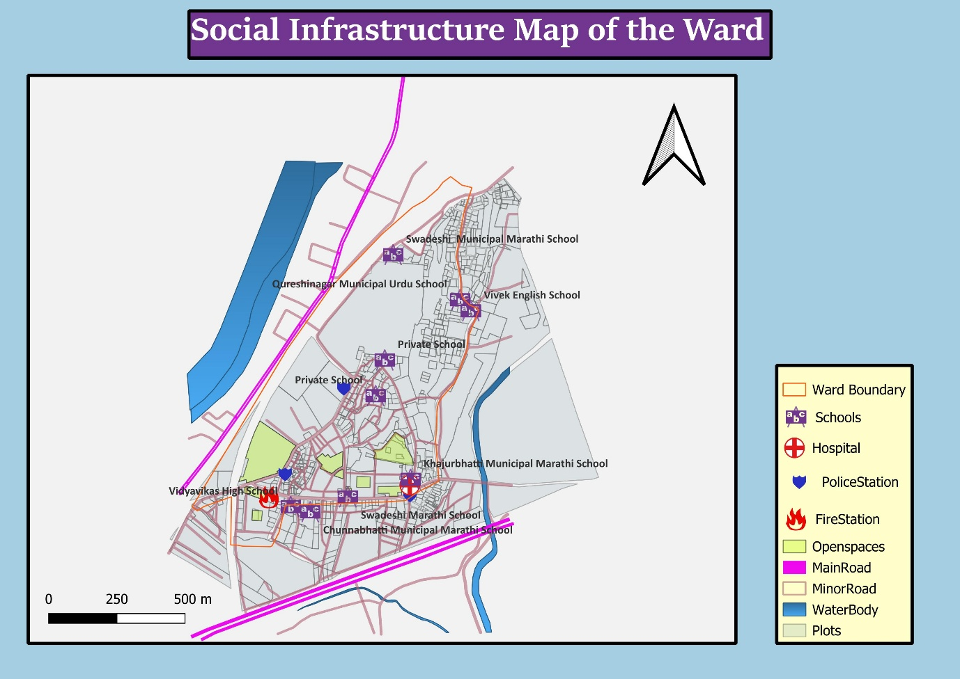

5. Section 4: Safety Assessment - Fire Station Response Coverage
This is the critical "Risk" layer. By applying a 500-meter buffer analysis to the fire station, we assess whether the essential services identified in the previous section are actually safe.
Critical Gap: The analysis reveals a major vulnerability. Only a small cluster of facilities near the fire station lies in the "Safe Zone". The local hospital and the majority of schools fall into the "Unsafe Zone," showing a severe service gap in the north and east of the ward.

Figure 4: Safe & Unsafe Zone: Fire Station Coverage (500m)
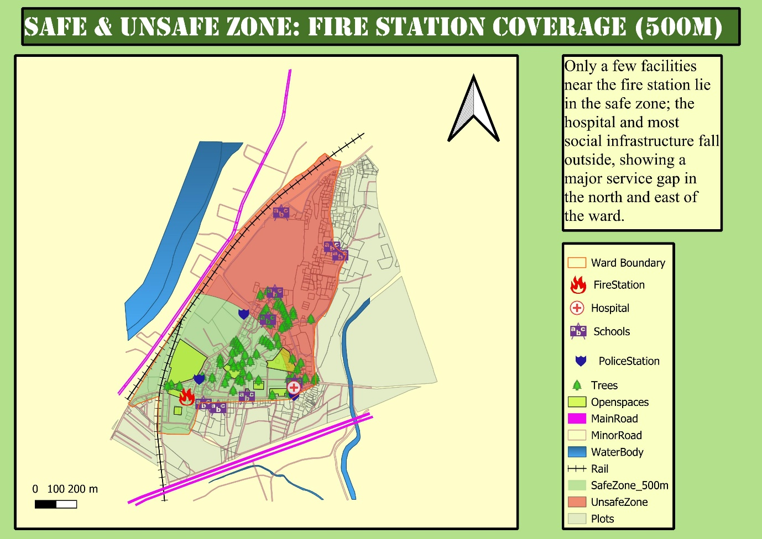

6. Section 5: Environmental Risk and Infrastructure Expansion
Finally, we look at future development. As the ward seeks to improve the roads mentioned in the base map, there is an ecological cost. This map uses a 5-meter proximity buffer to identify at-risk greenery.
Insight: Trees within 5 meters of minor roads are flagged as at-risk due to proposed widening. High concentrations of "Trees to cut" (red icons) signal zones where infrastructure expansion directly conflicts with the local ecosystem.

Place Figure 5: Trees Within 5m of Minor Road
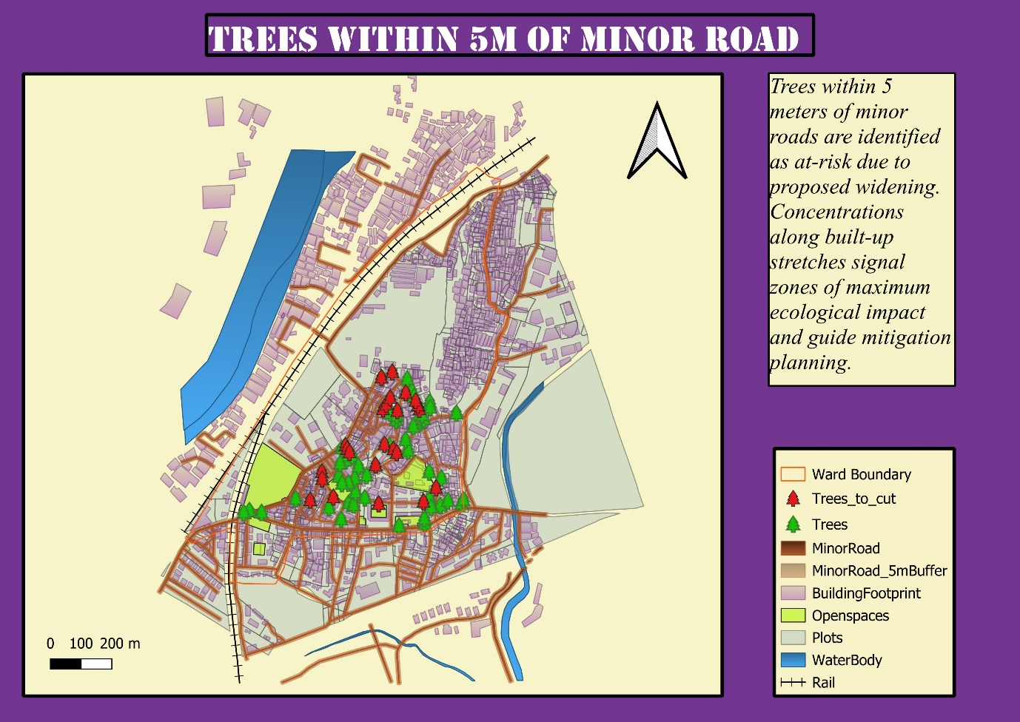

7. Summary of Findings and Strategic Recommendations
- Safety Realignment: Relocating or establishing a satellite fire post in the northern sector is required to cover the hospital and schools currently in the "Unsafe Zone."
- Balanced Expansion: Road widening projects must include a compensatory afforestation plan to offset the loss of trees identified in the 5m buffer zones.
- Infrastructure Utilization: The high density of municipal schools suggests the ward is a young demographic hub, requiring strengthened pedestrian-safe corridors around these clusters.

